Planning a game

A game is being developed that allows the player to move their character around the world, collect items, and cast spells. Help solve this problem using computational thinking.

Task . Decomposition - Break down the problem

The character in the game needs to be able to perform certain actions and each action needs to be handled differently by the game.

One of the requirements for this game is that the player needs to be able to move using the commands forward, turn left and turn right. The player should be able to pick up, use, and drop an item. The player should also be able to cast a spell and learn new spells.

The actions that the player can perform have started being broken down into smaller problems so they are easier to solve. Complete the table for the required player actions.

**Player Actions**

| **Move** | **Item** | **Spell** |
| --- | --- | --- |
|  |  |  |
|  |  |  |
|  |  |  |

Task . Abstraction - Remove the unnecessary information

A graphic artist has designed part of the town which the player can explore, shown below.

The programmers want to test the movement of the player around this part of the town. They don’t need all of the town details, just the buildings and paths.

Draw a simpler version of the map with all the unnecessary information removed.

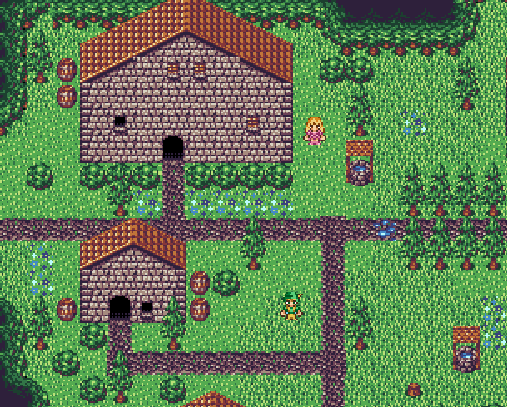

Task . Algorithmic thinking - Write a step-by-step solution

The command **forward** can be used to move the character forward in the direction that it is currently facing, and the character will stop moving forward if it reaches a split in the path or a door.

The commands **turn left** and **turn right** can also be used to change the direction relative to the character e.g. if the character is facing to the left, the command **turn right** will result in the character facing up.

Write down the order of the movements that the character should follow to go from the large building to the small house, travelling along the path.

|  |
| --- |